Congrats you got shortlisted for interview for IT Product Analyst

Company name: Inspire-Tech Pte Ltd
Position applied: IT Product Analyst
Date: Thurs 20 Sep 2018
Time: 2pm
Person to look for: Padma or Sharon
Expected Salary: $3000 (state in cv sent over)

Website: https://www.inspire-tech.com/

Things to bring along: NRIC, Original and photocopy of Educational Certificates, Copy of resume, Last drawn Payslip.

Address: 970 Toa Payoh North #05-03/04 Singapore 318992

Job Description
- Assist translating user and business requirement to product backlog.
- Review product releases and installers for customers.
- Gather technical and non-technical requirements and create test cases and test scripts to ensure quality performance.
- Create and support the development of technical documentation to educate end-users on how to use the product.
- Work collaboratively with potential customers to capture their technical and business needs.
- Build and maintain relationship with key personnel of prospects and existing customers.
- Work closely with marketing and sales on product updates and release announcements.

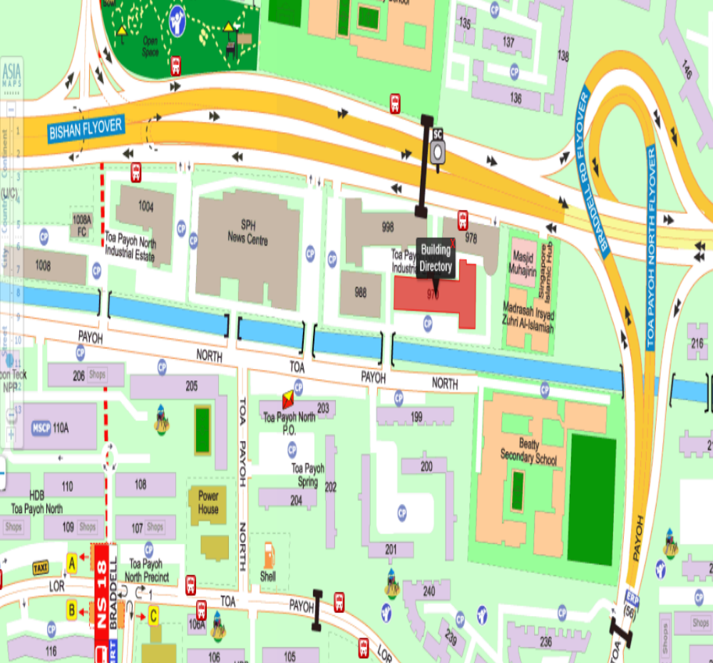

Address: 970 Toa Payoh North #05-03/04 Singapore 318992

Direction
Nearest MRT: Braddell MRT
Take Bus 88 from Toa Payoh Bus Interchange

